Apprenticeships are an excellent way to gain a nationally recognised qualification, get practical ‘hands-on’ work experience and valuable skills, all whilst earning a wage. Not only that, but you will also get the skills and knowledge employers need and a gateway to new opportunities.

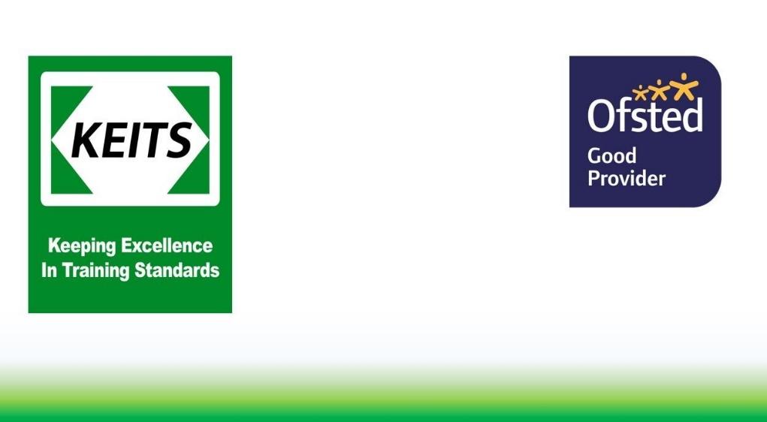

@KEITS_Training

@keitstrainingservices

KEITSTraining

KEITS Training Services Ltd

@KEITStrainingservices

**Level 2 & 3 Floristry Apprenticeships**

* Retail outlet
* Floral decorator
* Function & event design
* Exhibition Design

Within these roles you could find yourself requiring different skills & knowledge to:

* Create unique shop and window displays
* Ensure customer care & retail efficiency
* Source new suppliers
* Market effectively
* Follow floral trends & fashion
* Aid in business growth

**What could you do?**

Do you have a flair for design, or a passion for plants? If so, then floristry could be a great career for you!

Florists used creativity, artistry and knowledge of plants and flowers to create and assemble floral displays.

In order to succeed as a successful florist you’ll need to have an eye for detail, strong communication and customer service skills and enthusiasm for flowers, plants, colours and textures.

Would this suit you?

Apprenticeships give you experience in the working world and shows employers that you can ‘hit the ground running’.

Hands-on training gives you a real chance to put your skills into practice and helps you to gain more confidence in a working environment.

You earn while you learn. You’ll be paid an Apprenticeship wage by your employer, which will include your training.

Choice. You can begin to specialise in your area of interest straight away, alongside the basics of animal care work.

Apprenticeships offer a varied learning experience. You won’t have to spend all your time studying; most of the time you’ll be learning while you work and learning from others in your industry.

Why do an apprenticeship?

Working with animals is a popular career choice, so there is likely to be a lot of competition for job roles and Apprenticeships.

Kick-start your animal care career with an employer that invests in you, check out the vacancies on our website or social media pages.

**Working as a florist is a popular career choice, so there is likely to be a lot of competition for job roles and Apprenticeships.**

**Kick-start your animal care career with an employer that invests in you, check out the vacancies on our website or social media pages.**

Securing your apprenticeship will often involve a recruitment process and these can be very competitive, with many applicants chasing one position. CVs, applications, and interviews advertise your value to their business.

This is your chance to convince the employer that you are the right person for the job; selling your skills, demonstrating passion and making sure they know what you can bring to their business.

Getting that Apprenticeship

Check for spelling and grammatical errors. If you are careless on your application, what’s to say that you won’t be careless at work?

Draft your application offline in Word and save it. You can spell check, have a copy saved and, if there's a problem, you don’t have to start all over again! Save or print out the finished form - you will then have a record of what you've written for your interview which you can adapt for future applications. check for each job role and adapt to suit.

Remember... this is the employers first, and potentially the only introduction to you, so you need to make sure you create a great impression.

**Some hints…**

Is it feasible? Can you get there every day? Can you work the hours? Do you have to work late nights or weekends?

Is it realistic? Will you be happy working outside in winter? Can you cope with early mornings? Do you have the skills and knowledge they are looking for?

Find out as much as you can about the business. What does the business do? Who are their customers? Can you see yourself working there day-in-day-out?

**Before you start you should check…**

Plan what you are going to write. What skills, qualities or experience have they asked for in the advert and/or person specification?

What are your strengths? Why do you want this job? How do they link to the role? Think and plan. Look on websites for advice: monster.com or National Careers Service for example.

If you don’t have much experience yet - think about transferable skills you have and that all business need: customer service, IT and team working etc.

What other experiences do you have that can link your skills to the job role? Are you member of a club, or were you at school? Do you volunteer or help anywhere? Where possible, use examples to back up statements. Whatever you write or say… Prove it!

**Selling yourself…**