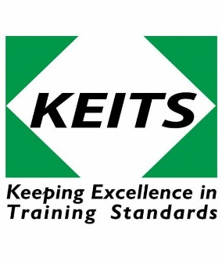
Certificate Of Competence

NPTC Level 2 Award in Safe Use of Pesticides (0216)
0216-54 151 safe use of Pesticides (PA6)

Course Date: LOCATION: Highfield Park, Highfield Lane, St Albans AL4 0RE What3Words useful.cave.lake.

Assessment Date:

Business Name: | Contact Name: | Learner contact details:
Address: | T:  M:  E: | T:  M:  E:

Registration Date & Candidate/s Numbers (KEITS use only)

Delegate/s Details:

Delegate/s Name:  In CAPITALS | Candidate/s Address: CAPITALS inc Postcode  & Contact Mobile number.  Next of Kin contact details. | D.O.B | Gender  M / F | Course Cost: | Payment received?  KEITS use only
 | NOK |  |  | £302.40Inc. VAT  PA6 Only
 | NOK
 | NOK
To process the application, each candidate MUST send a jpg photograph (mobile pic of head & shoulders (plane background, no hats or sunglasses) of themselves to Emma.bridgen@keits.co.uk.
Candidates must bring with them proof of address and photographic ID to attend the course and assessments.
Unless otherwise agreed by KEITS, course bookings will not be processed until payment has been received, at least 2 weeks prior to the start of the course. All Participants must agree to follow KEITS H&S protocol.
Prerequisite, it is necessary to be competent at reading, writing, understanding, and speaking English, along with basic numeracy skills. NPTC PA1 must be achieved prior to registering for NPTC
I confirm that the candidate/s nominated is/are suitable for training within the provision of the Health & Safety (First Aid) regulations 1981.

I also agree to be bound by KEITS Ltd to the terms and conditions. Any misspelt names at time of booking resulting in the necessity of new certificates, the cost of a new certificate being issued will charged to the employer/candidate. KEITS aspire to be an equal opportunities training provider and encourages bookings from individuals from under-represented minority groups.
We accept payment by  VAT: 948 5693 61  Company registered address: 10 London Mews, London, England,  W2 1HY. Company reg. no: 3387664 | Card payments please phone: 0208 327 3800  Please return completed form to:  Emma.Bridgen@keits.co.uk

